FOLLOW THE M.A.P.
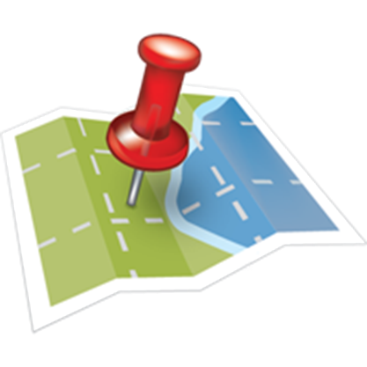
Maintain Good Health
Acquire Freedom
Protect The First Two

Three Maxims (general truths)
- Those that don’t know are at the mercy of liars.
- Before you can learn, you must unlearn…i.e. you must first deprogram before you can reprogram.
- Knowledge is NOT power. Knowledge combined with ACTION creates the power to achieve a desired outcome.
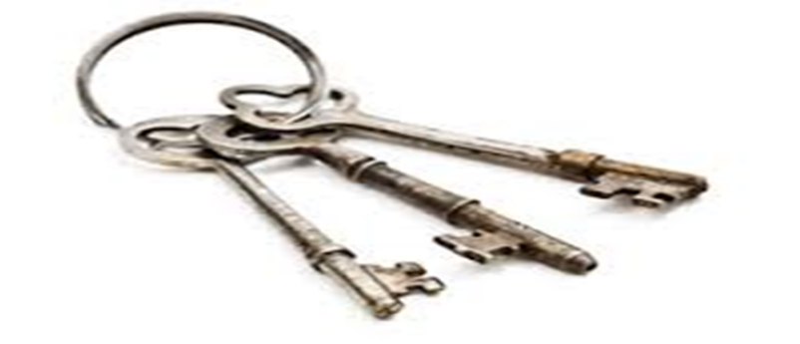

Three Keys to Freedom
- Health: Your body is your spiritual temple and currently the only place where you truly reside. Become a fanatic about your health because realistically we don’t own anything, except our bodies. In fact, the property you are on at this very moment doesn’t belong to you. Stop paying the tax and see what happens.
- Law of Necessity: Gathering resources is essential for survival. Money doesn’t mean everything, but its right up there with oxygen. People must have a means in which to generate resources for themselves and their posterity. This is as old as the caveman. A fire to keep you warm, food on the table, a roof over your head, clothes on your back etc.,
- Self-Determination: A process one goes about to control their own destiny. We are each accountable for our own selves. If I can’t take care of me, how am I going to even begin to try to take care of someone else?
These three keys need to work synergistically to maintain good health, acquire more freedom (time, financial, individual, political or any other kind of freedom), and to have the capabilities and standing to protect both.
“YOU NEVER CHANGE THINGS BY FIGHTING THE EXISTING REALITY.
TO CHANGE SOMETHING, BUILD A NEW MODEL THAT MAKES THE EXISTING MODEL OBSOLETE.” ― R. BUCKMINSTER FULLER
“WE CAN NOT SOLVE OUR PROBLEMS WITH THE SAME LEVEL OF THINKING THAT CREATED THEM.”
“THE WORLD AS WE HAVE CREATED IT IS A PROCESS OF OUR THINKING. IT CANNOT BE CHANGED WITHOUT CHANGING OUR THINKING”
"INSANITY: DOING THE SAME THING OVER AND OVER AGAIN AND EXPECTING DIFFERENT RESULTS."
—ALBERT EINSTEIN

7 MAXIMS OF HEALTH
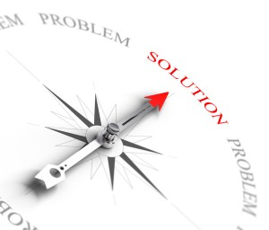
MAXIM 1
Let Food Be Your Medicine
Hippocrates, the “founding father of modern medicine” made the astounding connection with food and how it could heal the body. Food is the foundation of our health. Food fuels our cells and organs. If we ingest toxic and dead food, then guess what happens to our bodies? Yes, they become toxic, diseased and die prematurely. Discover the foods that will turn on your healthy genes and learn to focus on foods that alkalize and balance your body and drink structured water when possible.
“Let food be thy medicine and medicine be thy food.”
– Hippocrates.
MAXIM 2
Reduce Your Toxic Exposure
We now have research that shows 95% of all cancer is due to nutritional deficiencies and the accumulation of toxins. The water we drink has CHEMICALS added to make it “safe”, additives, preservatives, pesticides and fungicides, GMO’s (genetically modified organisms) food colorings and dyes are all DAMAGING our cells. There are many simple steps that you can take in order to reduce your daily exposure to environmental toxins in your home and in your body. Detoxification of the liver and colon play a major role in improving your health.
MAXIM 3
Balance Your Energy
"If you want to find the secrets of the universe, think in terms of energy, frequency and vibration"
- Nikola Tesla
Everything is energy. In fact, according to a Nobel Prize Laureate, Carlo Rubbia, we are only 1 billionth physical matter…the rest is ALL energy. If the foundation of the body is energy and light, then it makes sense that we keep that energy balanced and free of interference. Your Brain and Central Nerve System (CNS), your Acupuncture Meridian System and your hormones have a huge impact on the body’s energy system.
“Look well to the spine for the cause of disease.”
- Hippocrates
MAXIM 4
Heal Your Emotional Wounds
Have you ever felt stressed out about something and you noticed that your neck muscles or jaw felt really tight? Remember feeling that pit in your stomach or that ache in your solar plexus? The truth is that we are in the flight or fight response mode most of the time. That is an example of your “e-motions” or “energy in motion” getting stuck. Scientists have speculated about the emotional connection to dis-ease for years, but now with the study of “psycho-neuro-immunology”, we understand how stress impacts our health. In fact, we now have proof that your DNA contracts and relaxes in response to your mood. There are simple techniques to effectively manage stress and improve your happiness.
Examples:
- Wim Hof breathing
- EFT Tapping

MAXIM 5
Embrace Biological Dentistry
Your teeth are an intricate part of your body…not a separate entity that can be drilled, poked and stuffed with toxic poisons, without having an impact on the rest of your body. Amalgam fillings do NOT belong in your mouth because of the high mercury content. Mercury is one of the most toxic substances on the planet and the effect on the Immune System and overall health have been well documented. There is a relationship between specific diseased organs and the dental meridians.
MAXIM 6
Repair Your Body with Therapeutic Plants
The use of medicinal plants is well documented throughout history. Specific plants and herbs contain special compounds that nourish, stimulate, tone, strengthen, detoxify and speed up the healing process. In fact, there are specific plant compounds that actually kill cancer cells without harming the healthy cells of the body!
When certain naturally occurring compounds are synergistically blended they have the ability to interact with hundreds of genes which can then regulate (turn on and off) specific genes, such as anti-inflammatory vs. pro-inflammatory gene markers, and anti-fibrotic vs. pro-fibrotic gene markers. Certain pathways in the body are waiting to be activated if you give your body what it needs to heal itself.
MAXIM 7
Intervention & Prevention
Research and data compiled over the last several decades has shown us that taking countermeasures to avoid chronic illness before it manifests is far more effective than combating dis-ease once it has become unmanageable. Understanding which genes and pathways are the major players’ in pathology is key to mounting an effective plan of action. It's easier to stop something from happening in the first place than to repair the damage after it has happened.
“An ounce of prevention is worth a pound of cure.”
Benjamin Franklin

ACTIVATE YOUR PEAK POTENTIAL
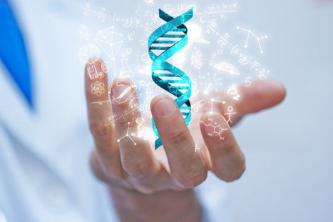
Reality is what we take to be true. What we take to be true is what we believe. What we believe is based upon our perceptions. What we perceive depends upon what we look for. What we look for depends on what we think. What we think depends on what we perceive. What we perceive determines what we believe. What we believe determines what we take to be true. What we take to be true is our reality.

STEP #1: Have Clarity of Purpose
Your brain is a goal-striving organism, meaning it will always strive to prove you right. Henry Ford once proclaimed, "Whether you think you can or you think you can't, you're right!" What he understood is that if you don't believe it, your brain can't achieve it.
Having goals in life is important, but you must believe it's possible, and you must believe it's worth it. High performance people almost always have one big audacious why that drives them; it's the all-important, all-consuming reason they do what they do. It's why they get out of bed earlier than everyone else, why they are willing to burn the midnight oil to get a project to the finish line, and why they pick themselves up, dust off, and keep going no matter how hard they've been knocked down.
So what’s your why? Is it big enough? Is it audacious enough? Does it get your juices flowing? Is it big enough to carry you through the rough patches?
The first step to finding out your why is to find out who you really are.
STEP #2: Commit To the Process
Most people fail at obtaining their goals because they are committed to the outcome and not the process. We live in a society where instant gratification is the norm. Commit to the process of being happy and detach from the outcome. When the outcome seems like it’s taking forever and people don’t see instant results they stop believing and give up. Put all your commitment and trust is the process because that is what you’ll celebrate when you get the outcome.
People who make short term decisions with the end in mind reap the long term benefits of those decisions. They master short term priorities while keeping a long term perspective in mind.
This same principal can be applied to education, money matters, stopping smoking, or any other goal. Disciplining yourself to do what you know is right and important, although difficult, is the high road to pride, self-esteem and personal satisfaction. I don't know of anyone who would leave those qualities out of a future they would design.
You can have anything you want if you want it desperately enough. You must want it with an inner exuberance that erupts through the skin and joins the energy that created the world.
STEP #4: Manage Emotions
There is really only one way to manage emotions, and that is by managing stress. Emotions are really energy in motion, and if your brain is always busy coping with stress, there's not enough energy left for performance. We are living in the most stressful time in human history. Our world is fast-paced and high-tech. On average, people pick up their smartphones 150 times a day; and if you've ever watched someone who has lost their smartphone, you’ve seen what a stress response looks like.
Stress happens in our heads, not by external forces, because we are responsible for how we react to certain situations. It’s not the event, but rather how we respond.
Therefore, our thoughts and actions control how much stress we experience. That’s good news because if we can control how we react then we can control the amount of stress that occurs in the first place.
Your brain’s system of coping with stress is part of our survival instinct. In this day and age, when stress is constant and intense, the brain sets up a pattern of perpetual coping that depletes its resources and restricts your ability to think, focus, remember, be creative and inspired, or otherwise perform optimally.
Finding ways to induce the relaxation response in the body will quit the mind which will then quit the body triggering the release of certain neurochemicals, which neutralize chronic stress.
STEP #5: Eliminate Fear and Doubt
Have you ever stopped to consider what really stands between who you are today and who you wanted to become? You're probably thinking the answer is fear, but it's not. The answer is you! It's you and your relationship to fear ... and your relationship to doubt ... your doubt that you have what it take to accomplish your goals or live the life of your dreams.
Fear is not real. It is a product of thoughts you create. Do not misunderstand me. Danger is very real. But fear is a choice.
Is fear really a choice?
In order to answer that question, let’s first take a deeper look at the nature of fear.
What is fear, really? Have you ever wondered where it goes when it’s not there anymore? Or where it comes from in the first place?
One of the most interesting things about fear is that it always seems to either come from something outside of us (an environmental stimulus) or from something inside our heads but separate from us – the “psychological bogeymen”.
When you look closely, you’ll find that every fear you experience is actually made of thought. It’s not “false evidence appearing real”, as the acronym suggests – it’s thought appearing real. It’s how react to the thought.
Imagine waking up from a nightmare. One moment you’re totally engrossed in fighting off vampire zombies and the next your eyes are open and the vampire zombies are gone.
You may still have a little bit of adrenaline coursing through your veins, but there are no lasting after-effects. No healing is necessary. You just get up and get on with your day.
We notice a scary thought in our mind, and because we do not recognize thought as the creator of the feeling, we are run ragged by it. We do all sorts of things to avoid an imaginary consequence that has been constructed in our own mind. But the moment we recognize that only thought can create feeling, the very same thing that was so frightening becomes fascinating.
And the same possibility for freedom exists at the heart of all fear. The moment we see that our own deepest, darkest fears are 100% made of thought, we open up the space in our minds for our innate health, wisdom, and well-being to come through.
There may well still be things to do in the world to create the outcomes we desire – but we will do them based on what is actually wanted and needed in each situation, not as a knee-jerk fight or flight response to our own unrecognized thinking. And in the very moment we recognize that thought is the only creator of our experience, the same world that once seemed so frightening becomes an endlessly, wonderfully fascinating place to be.
Which brings us back to our initial question:
Is fear really a choice?
In those moments where we recognize thought as the source of our fear, we can choose whether or not to indulge them – but that’s like saying you have a choice between hitting yourself in the head with a 2×4 and not hitting yourself in the head with it. In those moments where you’re aware that’s where your headache is coming from, you’re extremely unlikely to choose to keep doing it.
Since we don’t even know what we’re going to be thinking sixty seconds from now, it’s apparent that the vast majority of the time, we don’t choose our thoughts. And since fear is made of thought, it seems to me that the majority of the time, we don’t really choose whether or not to feel afraid.
But here’s the good news: Since we can at least intellectually recognize that the source of all fear is thought, we don’t have to make a big deal out of being afraid. We don’t need to hide from seemingly scary things, but rather “feel the fear and do it anyways”.
We can simply move forward in the face of ever changing thoughts, including the scary ones. And because we’re not scared of fear, we are left with something even more powerful than choice – true and absolute freedom.
Step#6 Eliminate Anxiety and Regret
The Past
Man’s past exercises great power over his existence in the present. Yet, the past no longer exists. Mankind cannot alter the past with all the power in the universe. But like the chains of Marley’s ghost man often insists upon dragging the past into the present.
“Yesterday is history, tomorrow is a mystery, today is a gift of God, which is why we call it the present.”
― Bill Keane
Man creates his own burdens. He is never really in the present because he will never let go of the past long enough to truly be free. Every second is spent slightly out of sync because he is never really entirely in the moment. He is consistently distracted and eschewed from the fullness of the moment because he insists upon dragging the past in his own thinking.
“He who can alter my state of mind, is my master.”
― Ralph Waldo Emerson
The Future
Should you worry about the future? Our concern about the future which has not yet arrived makes us a slave to our thoughts. We imagine the future on the screen of your own mind with little knowledge or awareness of who is controlling the projection of that display. You think therefore you imagine you understand.
The present is the only place you will find a solution for the future or the remedy for the past. If you are to remain balanced you must return to the present.
The Present
When we focus on past events we create regret. When we focus on the future we create anxiety. The present is just that, a present. Live in the here and now!
“It's being here now that's important. There's no past and there's no future. Time is a very misleading thing. All there is ever, is the now. We can gain experience from the past, but we can't relive it; and we can hope for the future, but we don't know if there is one.”
― George Harrison
No matter how out-of-control your day is, no matter how stressful your job or life becomes, the act of being present can become an oasis. It can change your life, and it’s incredibly simple.
Sure, there are external forces at work: an uncontrollable job, the stress of kids and chores and interruptions and digital distractions. But it’s how our mind handles those external forces that is the problem.
If you are completely present, the external forces are no longer a problem, because there is only you and that external force, in this moment, and not a million other things you need to worry about.
If your kid interrupts you, you can stress out because you have other things to worry about and now your kid is adding to your worries or interrupting your calm. Or you can be present, and there is then only you and the child. You can appreciate that child for who she is, and be grateful you have this moment with her.
If your job demands that you focus on an urgent task, you can stress out because you have a million other things to do and not enough time to do them. Or you can be present, and focus completely on that task, and now there is only that one task and you. When you’re done, you can move on to the next task.
Social media and other digital distractions don’t interrupt us if we close them and learn to pour ourselves completely into the present task. And if we need to do email, Twitter, or read blogs, we can set aside everything else and just be present with that one digital task.
Being present becomes, then, a way to handle any problem, any distraction, and any stressor. It allows everything else to fade away, leaving only you and whatever you’re dealing with right now.
Practice
Repetition is the mother of all wisdom!
“We are what we repeatedly do” Aristotle
When you practice something regularly, you become good at it. It becomes more a mode of being rather than a task on your to-do or someday list.
Whatever you’re doing, right now, learn to focus completely on doing that one thing. Pay attention to every aspect of what you’re doing, to your body, to the sensations, to your thoughts.
Be joyful, and humble in whatever you’re doing, grateful that you’re able to do that task, and fully appreciate every little movement and tactile sensation of the task. You’ll learn that anything can be an amazing experience, anything can be a miracle.
Here are a few examples:
- Do one thing at a time. Single-task, don't multi-task. When you're pouring water, just pour water. When you're eating, just eat. When you're bathing, just bathe. Don't try to knock off a few tasks while eating or bathing or driving. Zen proverb: "When walking, walk. When eating, eat."
- Do it slowly and deliberately. You can do one task at a time, but also rush that task. Instead, take your time, and move slowly. Make your actions deliberate, not rushed and random. It takes practice, but it helps you focus on the task.
- Do less. If you do less, you can do those things more slowly, more completely and with more concentration. If you fill your day with tasks, you will be rushing from one thing to the next without stopping to think about what you do. But you're busy and you can't possibly do less, right? You can. I've done it, and so have many busy people. It's a matter of figuring out what's important, and letting go of what's not.
- Put space between things. Related to the "Do less" rule, but it's a way of managing your schedule so that you always have time to complete each task. Don't schedule things close together -- instead, leave room between things on your schedule. That gives you a more relaxed schedule, and leaves space in case one task takes longer than you planned.
- Spend at least 5 minutes each day doing nothing. Just sit in silence. Become aware of your thoughts. Focus on your breathing. Notice the world around you. Become comfortable with the silence and stillness. It'll do you a world of good -- and just takes 5 minutes!
- Eat slowly and savor your food. Food can be crammed down our throats in a rush, but where's the joy in that? Savor each bite, slowly, and really get the most out of your food. Interestingly, you'll eat less this way, and digest your food better as well.
- Live slowly and savor your life. Just as you would savor your food by eating it more slowly, do everything this way -- slow down and savor each and every moment. Tune into the sights and sounds and awaken your senses to the world around you.

STEP #6: Be Flexible
The number one obstacle to optimizing your brain's peak potential is being stuck in old routines ... This is what you have always done on Monday or Wednesday ... this is the route you always drive home from work ... this is what you always do on the weekends, and so on.
It's easy to get into comfortable ruts, but your brain ends up in a rut with you and starts losing the neural pathways that are no longer active. When people get too routine-oriented, any time they are pushed out of that comfort zone, it can be quite stressful. This is because the brain no longer has the flexibility to meet new challenges head on. Seniors need to be especially mindful of this. When people retire, they tend to fall into daily habits and their brains lose resiliency. Thus the old adage, "You can't teach an old dog new tricks."
Fortunately, science has now proven that our brains retain neuroplasticity all our lives. This means we can keep our neurons firing and wiring together at every age.
We can continue to build new neural networks, and enjoy a great quality of life at every age. In other words, you can teach an old dog new tricks! This is why it's so important that you open the door to the subconscious every day by turning on your imagination. Visualizing all the positive new things you can do awakens you to the opportunities you have for achieving your goals. The brain doesn't know the difference between real and imagined, so whatever you conjure up will work to activate the neuroplasticity of your brain.
So now you know the whole idea behind visualization. Using the power of your imagination, you will practice new success habits and behaviors so well, that your brain will perform for you like a well-oiled machine.
Look at it this way: while no one can predict the future, by using your natural ability to imagine, you can interact with it. Success may not show up quite the way you fantasized it, but when your brain actively participates in success scenarios every day, it will have all the right neural networks to bring about success.
STEP #7: Balance Your Brain for High Performance
While there is a wide assortment of relaxation and visualization methods-progressive relaxation, meditation, autogenic (self-produced) training such as self-hypnosis, and biofeedback to name a few-most of these take conscious effort.
With the breakthrough of light and sound brain training technology, you don't have to "believe in "or "do" anything. Through frequency following response, the brain "syncs" to the gentle light strobes and embedded tones. You are in the experience and don't have to create it.
Negative thoughts, habits, and stress are the enemies of the brain. You can't expect to have peak brain performance when it's busy managing the flight-or-flight response that's inherent in your overloaded lifestyle. In order to overcome the brutal effects of stress, you must achieve the relaxation response, and it needs to happen every day.
You can't get into the relaxation response while generating beta brain wave activity. Your brain wave activity must dip into alpha, the intuitive mind, and theta, the inventive mind.
In modern society, due to our environment and lifestyles, nearly everybody's brain has habituated to high beta activity with little or no alpha or theta, which means few people ever engage the intuitive or inventive capabilities of their brains.
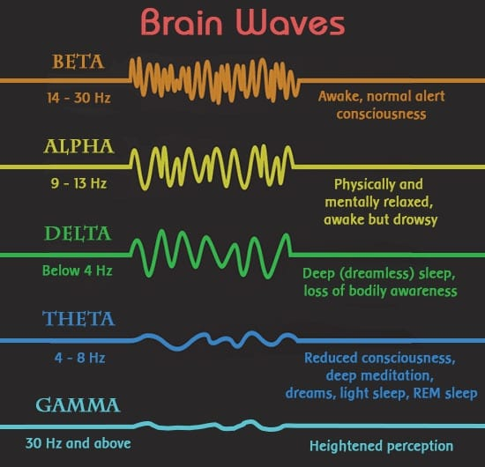
Many people believe that theta is the optimum state for creativity and that it's the only place one can make a quantum leap in consciousness. But the theta state is difficult to maintain. When you slip into theta (4-7 Hz), which everyone does at least twice each day (right before falling asleep and just before awakening), and when there are no beta or alpha frequencies mixed with the theta, most people lose consciousness. This is where frequency following response comes in-it keeps your brain engaged and balances brain wave activity.
When people use light and sound technology, they often describe feeling as if their inner experience is more real than the outer experience, which is temporarily suspended.
Most importantly, by training your brain to operate in a full-spectrum balance of brain wave activity, you'll have a brain fortified for endurance and optimized for exceptional cognition, creativity, and inventiveness.

The 5R-System
As developed by Dr. Tracey Stroup
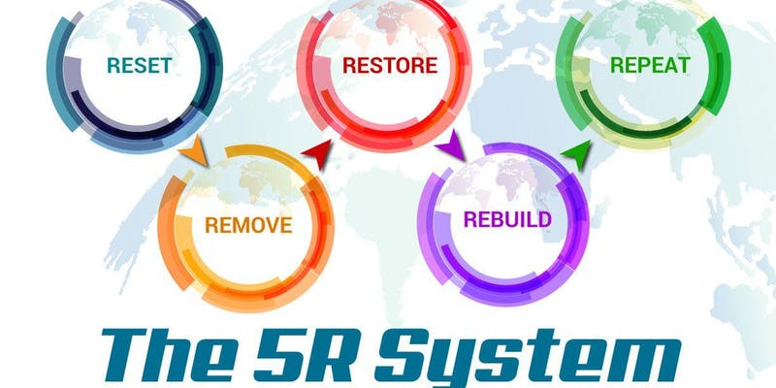
RESET – REMOVE – REBUILD – RECHARGE - REPEAT
RESETTING means prepping the body for what is to come:
- REMOVAL of toxins built up in the body
- REBUILD systems through nutrition, action, emotional and spiritual wellness
- RECHARGING the mind, immune system and adrenals to continue the plan
- REPEAT the process as many times as needed until the body is restored to an optimal state of wellness

Understanding the 5R-System
Foundations of Health
Nutrition – If it falls from a tree, grows from the ground, runs in a field, swims in the water or flies in the sky; organic and non-genetically modified, EAT IT!
The Modified Mediterranean Diet
The Mediterranean Diet tied for first place in the 2018 U.S. News & World Report Best Overall Diet category. It also ran away with the top honor for the easiest-to-follow diet.
The Mediterranean Diet consists of large amounts of fresh vegetables and moderate amounts of fruit, in addition to whole grains, beans, nuts, and seeds. Fish, and to a lesser extent lean meat and poultry, are eaten in moderation.
Red wine can be consumed in moderation. A plate of food should look fresh and colorful. The more different colored vegetables there are on the plate, the wider the array of health-promoting antioxidants and flavonoids there are hiding inside.
Fresh fruit is the typical daily dessert, and organic extra virgin coconut oil and organic extra virgin olive oil (a monounsaturated fat – MUFA for short) is the primary sources of fat.
The Mediterranean Diet discourages fried foods, hydrogenated oils, refined carbohydrates (baked goods from refined flour and sugary desserts), beverages with added sweeteners (sodas and juices), high-fructose corn syrup, and fatty, processed meats, such as lunch meat, bologna, and ham.
The Modified Mediterranean Diet goes a step further to help assure you are not including common allergens, such as gluten, in your diet that can contribute to inflammation and weight gain.
Chronic diseases
Very credible research shows the Mediterranean Diet provides protection against diseases such as heart disease, metabolic syndrome, diabetes, cancer, inflammatory bowel disease, cognitive dysfunction, and arthritis – all chronic conditions associated with inflammation.
Trials have shown that a diet that is high in MUFAs can definitely lower inflammatory markers, including tumor necrosis factor-alpha (TNF-α), metallo-proteinase-2, and nuclear factor-kappaB (NF-κB).
And it is well known that omega-3 fatty acids included in the diet from fish, the antioxidants from fresh vegetables, and the flavonoids from berries and other fruits also exert an anti-inflammatory effect on the body.
Persuasive evidence also supports the Mediterranean Diet as an “anti-cancer diet.” In one study, 250 women with newly diagnosed breast cancer were compared to women of the same age who did not have cancer. Adherence to a Mediterranean Diet was assessed and found to significantly decrease breast cancer risk.
The factors that had the most influence on decreasing cancer risk were unrefined grains, vegetables, and fruits – all of which translate to high levels of dietary fiber and antioxidants.
Another study showed that women whose diet included more fish and olive oil had a lower risk of breast cancer than those women who did not. This same study also found an even stronger protective effect from eating a diet high in fruits and vegetables.
Vegetables and fruits are high in fiber, which creates a healthy intestinal environment by promoting beneficial bacteria and fatty acids. Fiber increases butyric acid levels in the colon – the fuel for colon cells.
A healthy level of beneficial bacteria can decrease inflammation in the colon and decrease the risk of inflammatory bowel disease and colon cancer. Fiber also improves bowel health because the by-products of food digestion don’t “sit” in the intestines and create toxic substances.
“Let food be thy medicine and medicine be thy food.” – Hippocrates
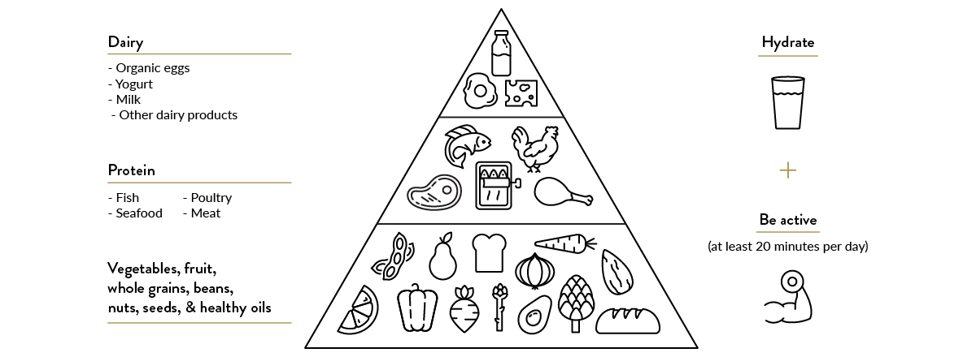
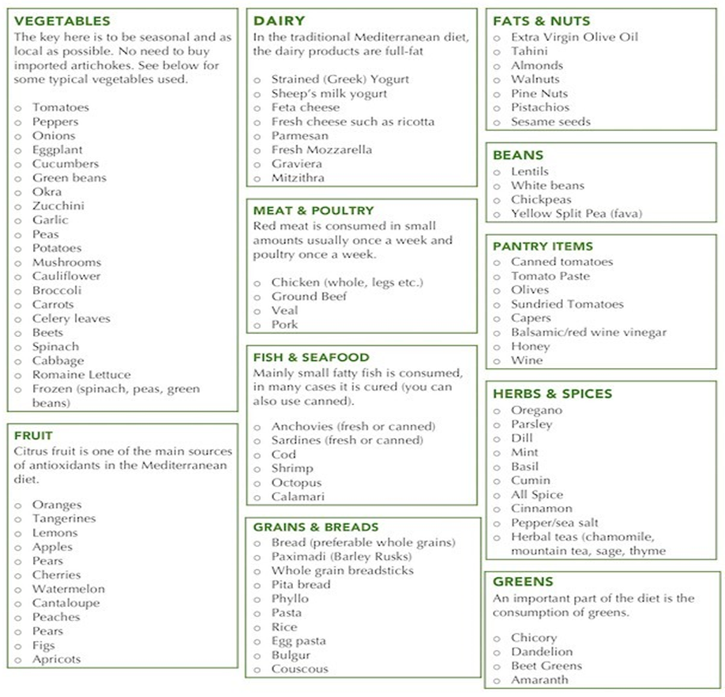

The modified Mediterranean diet is not a one size fits all. Versatility is the key, which is why this diet trumps all other diets.
Search: Modified Mediterranean diet recipes for breakfast, lunch, and dinner options to see what fits well for you.
Don't eat: Sugar-sweetened beverages, added sugars, processed meat, refined grains, refined oils and other highly processed foods.

Hydration - Our body is 60% water. It is the medium for every process in the body. Examples include assimilation, temperature regulation, transport of nutrients, cognitive thinking, mood, oxygenation of the body, keeping mucous membranes moist and detoxification. Our blood is 80% water; our brain is 70% water. Water is everywhere and needed for all things.
Hydrogen water (molecular hydrogen) - Hydrogen (H2) is the most abundant molecule in the Universe. Hydrogen water contains hydrogen molecules that can act as powerful antioxidants. These molecules may help neutralize oxygen free radicals that contribute to disease development, inflammation, and aging.
- Neuroprotective
- Excellent antioxidant
- Anti-inflammatory
- Protects organs
- Lowers cholesterol and blood sugar
- Improves a wide variety of diseases
- Is not toxic even at high concentrations
Sources:
- John Ellis Water — Hydrogen is the Fuel of Life! CHANGES THE HYDROGEN BOND ANGLE from 104 to 114 degrees so it’s easier for the “Body Electric” to split water into hydrogen and oxygen. 13 Patents 332 FDA Tests.
- HIM (Hydrogen Infusion Machines) — these home units use a special membrane called a Nafion membrane or PEM (proton exchange membrane). The units are specifically designed for producing and dissolving molecular hydrogen into highly-filtered water.
- H2 Portable Units (HIMs or ERW) — portable water bottles that produce and dissolve H2 into drinking water. These devices can generate neutral pH or alkaline pH hydrogen-rich water depending on the type. They are convenient and can produce hydrogen-rich water within 5 to 10 mins.
- Hydrogen Tablets — use elemental magnesium to produce molecular hydrogen. These metals are called alkali metals; they naturally react with water to produce molecular hydrogen. These tablets can be ingested or dropped into water to produce hydrogen rich water. They are a great way of producing higher concentrations of dissolved hydrogen in water, or to drink hydrogen water on the go.
Other water sources:
- Reverse Osmosis
- Spring water (avoid plastic bottling/ BPA’s-bisphenolA,)

Movement
Our bodies are designed to move. Movement is function, transportation and detoxification. We must redefine the mindset around movement and exercise from a vanity-focused industry to a health focused function.
Function of Movement
Every day we move our body to build neurological synapses. Consider it working out for your brain. Opposite arm to leg movements, like walking, stimulate the right and left side of the brain and keep communication flowing across the corpus callosum. Training your brain through movement is a real thing and quite necessary for the optimal function of our brains and bodies.
When moving emphasis should be on the value of simple walking, not for calorie burning, but for the old adage if you don’t use it you lose it. This statement is very true.
Movement and Detoxification
When we talk about movement we are talking about a process of detoxification, not calorie burning. Again, this category has fallen victim to the market trends to sell you something. Calories are units of heat. Most toxins are fat soluble so they stick to fatty tissues such as the fat in your body, your brain and spinal cord. In order to remove them from the body, cells must be destroyed. This process is called autophagy.
Autophagy is your body’s way of identifying bad or old cells that no longer benefit the system. The body selects these cells for destruction by the immune system, utilizing the left over healthy parts to be used to enhance other cells. The three ways autophagy occurs in the body is intermittent fasting, ketogenic diet and exercise or movement.
Physical movement is one component of the whole; mind, body and spirit.

How Much Movement?
Daily movement is optimal and truly biologically required. But it does not have to be a throw down sweat fest. We simply need to move throughout the day. Movement should be cumulative. Of course there are great advantages to pushing the body limits but for the average person who the current system is failing, suggesting small bouts of movement are doable.
Frequency: Daily in some way move the body and lymphatic system.
Examples: Walking, running, dry skin brushing, rebounding, cycling, really anything that gets the body moving. Yoga, resistance training, circuit training, dancing, body weight movements, stretching, the list can go on and on.
Other examples:
- Kaatsu training
- Nitric Oxide Dump workout
- High-intensity interval training (HIIT)
Sleep
Sleep is the most under-appreciated health crisis in America.
Regardless of diet, exercise or water consumption, if one does not sleep they will not feel well or be able to attain optimal health..
How Much Sleep is Necessary?
Seven to nine hours of uninterrupted sleep is recommended for optimal health. Only 21% of the US population sleeps 7 or more hours.
Quality sleep leads to increased immune system function (greater T-Cell effectiveness), better identification of antigens, increased mental alertness, increased energy, increased wellbeing and facilitates maintaining a healthy weight.
Those who sleep less than seven hours experience more detrimental health and weight issues than those who slept seven hours or more.
Sleep and Circadian Rhythms: Getting Quality Sleep
Waking through the night for any reason can disrupt sleep and will impact normal circadian rhythms of the body.
Our body has a rhythm of processes. Every cell has it’s own clock under the rhythm of the master clock of your brain. This master clock is called the suprachiasmatic nuclease. Circadian rhythm is the process of synching these systems so all processes work together. This ancient clock of the body is tuned into our surroundings, primarily light and the pineal gland. As the sun goes down, our pineal gland is stimulated to release melatonin (our sleep hormone), which tells our body it is time for bed. Stress, environment, nutrition, hydration and many other things that keep our body running daily also affect these processes.
“Each night, when I go to sleep, I die. And the next morning, when I wake up, I am reborn.” ― Mahatma Gandhi
Disrupted Sleep
What Time are you Waking and what it Means?
According to Traditional Chinese Medicine (TCM), sleep patterns are a direct result of Qi energy of the body and organ function. Noting what time you wake each evening can give indication to an organ or system that needs support.
The Chinese Meridian Wheel shows the times and corresponding organ systems. Every organ is either yin or yang with the organ system directly across from it being the opposite. For example the liver is at the time frame of 1-3 am. This is a Yin organ, which is directly across from the small intestine (1-3pm), a Yang organ.
If you complain about waking up at 2 am every single night; or stating that you become tired at 3 pm every day, noting which organ or system needs support then triangulating those results can help determine the best supplement or nutrition regimen to support the body.
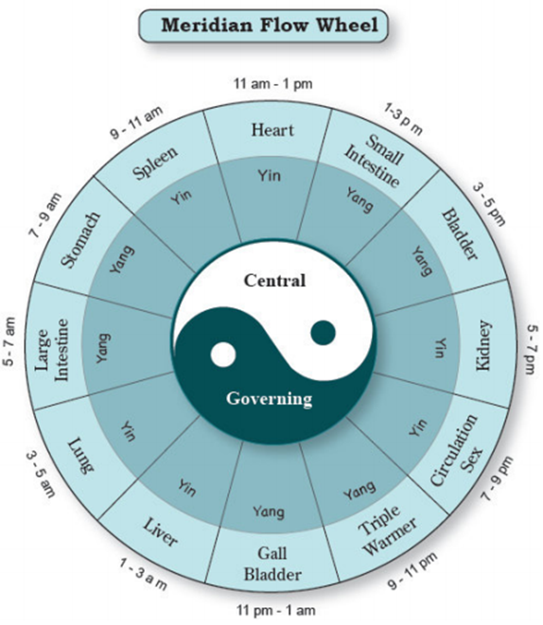

Sleep is a Platform for Detoxification, Recovery and Healthy Hormones
We detoxify and recover while we sleep. We also produce and regulate hormones. During the night body functions slow down and reset.
This is the primary time when short term memory converts to long term, our organs rest, the autonomic nervous system slows and our body repairs and recovers. This is our house cleaning time. The time when our body identify and destroys bad cells and utilizes Human Growth Hormone to repair cells and systems.
Researchers have found that during sleep, the brain even undergoes physical changes that allows the system to work faster. Brain cells shrink by 60%, increasing the space between them so the toxins can be flushed away more effectively.
Sleep is also a time of hormone regulation. We release specific hormones when we sleep and according to the National Institute for Health, these hormones control the following:
- Glucose regulation
- Appetite control
- Neuroendocrine function
- Cortisol release throughout the day
- Insulin sensitivity
- Levels of ghrelin (a hunger hormone released primarily from stomach cells)
- Levels of leptin (hormone released to repress appetite)
- Release and regulation of Human Growth Hormone
Disruption of sleep leads to disruption of hormone regulation. This offset may lead to blood sugar instability throughout the day, weight gain due to offset of ‘hunger hormones’, inability to recover, mood issues due to high cortisol, heart stress and general feeling of unwell to name a few. People who sleep less than seven hours per night have an average weight gain of 10 pounds per year. If nothing else caught your attention from the list, weight gain is normally one that will hit home for people.
Human growth hormone (often abbreviated HGH or hGH) is yet another reason to get good sleep. HGH is a complex protein produced by the pituitary gland in the brain and is an important part of the body’s endocrine system. HGH is released by the brain into the bloodstream during sleep, and its release is part of the repair and restoration function. Human growth hormone promotes a healthy metabolism, enhances your physical performance, repairs cells and may even help you live longer.
Early to bed, early to rise, makes a man healthy, wealthy and wise.”
― Anonymous
A note for your children: HGH is especially active in the growing child’s maturation. HGH steadily declines with age so it is very important children have a regular bedtime and get good sleep. Although HGH is not the only physiological factor that makes kids get taller and grow, it does play a vital role in brain development, emotional wellness and physical recovery. Another reason to put those kids to bed early!
Support Your Endocrine System, Detoxify and Recover with Good Sleep
According to most recent studies by the Centers for Disease Control (CDC), a variety of health issues can arise from acute to chronic sleep issues. Some of those include:
- Obesity
- Heart attack
- Stroke
- Coronary Heart Disease
- Asthma
- COPD
- Cancer
- Arthritis
- Depression
- Chronic Kidney Disease
- Diabetes
“Adults who were short sleepers (less than 7 hours of sleep per 24-hour period) were more likely to report being obese, physically inactive, and current smokers compared to people who got enough sleep (7 or more hours per 24-hour period)”
Successful Sleep Tips:
- Have a regular bedtime
- Set the mood and environment
- When and what you eat matters
- Meditate or pray
- Dim the lights in the house
- Turn off the Ipads and smart devices
- Proper supplementations when needed
Other options:
Twilight: Blue light filter - Are you having trouble falling asleep? Are your kids hyperactive when playing with the tablet before bed time?
Are you using your smart phone or tablet in the late evening? Twilight may be a solution for you!
At night, blue light can suppress the secretion of melatonin and wreak havoc on our circadian rhythms. Blue light hits a molecule called retinal, it triggers a cascade of chemical reactions that could be toxic to cells in the retina of the eye.
There are two types of 'photoreceptor' cells in the retina responsible for detecting light: rods and cones. Rods make up the majority, and they rely on a protein called rhodopsin in order to detect light.
Blue light exposure at night triggers a distortion in an important protein in the cell membrane. This is followed by an increase in both oxidative damage and calcium levels in the cells. It's toxic!
Calcium signaling controls many aspects of our cellular biology including immune system function and inflammation.
Every year more than two million new cases of age-related macular degeneration are reported in the United States.

Setting the Stage for Optimal Sleep
In this fast paced world, we must learn to manage and control the parts of life we can actually manage and control. One of those parts is setting the stage for sleep. For some, adjusting some simple parameters can make all the difference.
- Have a regular bedtime and stick to it. So many people go to bed far too late. Quality sleep happens before midnight and this is due to the Circadian Rhythms of the body mentioned previously. Adjusting your bedtime to follow the natural phases of sunset to sunrise will set the stage for optimal health. It is a societal stigma that going to bed early is a sign of laziness or is uncool; when truly, a bedtime between 8:30 pm and 10 pm provides the best opportunity for Circadian reset.
- Set the mood and environment of your sleep space. Discovering and implementing your optimal environment for sleep is crucial for a good nights rest. Make sure your space is quiet, at a comfortable temperature with minimal light. If you enjoy reading, get into bed early to have 15 to 20 minutes to wind down. Remember the pineal gland is our indicator for melatonin release (our sleep hormone). It is stimulated by low light.
- When and what you eat matters. Our nutrition has a lot to do with our quality of sleep. First, we should be providing our body with real food (see Nutrition section) to assure nutrient density, giving our bodies every opportunity for all systems go! Second, avoid foods that may stress the body like sugar. Avoid non-food items that are processed, chemically laden and allergens.
- Last, a large meal should not be consumed two to three hours prior to bed. Not only will a person be uncomfortable with a large meal in their system but it puts the body in a state of increased function when sleep is the time for body processes to slow down and rest.
- Meditate or pray. Doing something calming as a regular practice can be very beneficial and set the mind to rest. This is a great way to start the process for falling asleep and staying asleep. Meditation builds the size and grey matter of the hypothalamus, the control center for the autonomic nervous system leading to lower stress and better sleep.
- Dim the lights and free yourself of electronics. Many people choose smart devices to wind down or read before bed. While scrolling through social media posts is fun, the LED blue light can confuse the pineal gland, decreasing the amount of melatonin to release and offsetting our normal circadian rhythm. One simple change of putting down the smart device an hour before bed, could make all the difference in quality sleep. We see this crisis growing in children due to the overuse of smart devices and LED exposure to the pineal gland. Sleep issues are increasingly becoming more problematic due to the high usage of smart devices. Do your pineal gland a favor and read a real book before bed.
Elimination
We are bombarded with toxins daily! Having the ability to eliminate these toxins from our body is vital for sustained health. There is so much emphasis in January for cleanse and detox programs. While these can be beneficial, many people are not prepared for the stress that a cleanse/detox can cause to their system.
Remember cleansing or detoxification is stress to the body, systems and organs.
RESETTING the body and getting the organs and systems prepared for the journey ahead is vital for a successful process. What is their body capable of handling? If our body is not ready or can’t handle the detox process, you may end up sicker or feeling worse. When we reset the body, we provide the education and foundations for all systems and organs involved to function to the best of their ability. Only then should we consider a cleanse or detox.
“If you don't take care of this the most magnificent machine that you will ever be given...where are you going to live?” - Karyn Calabrese
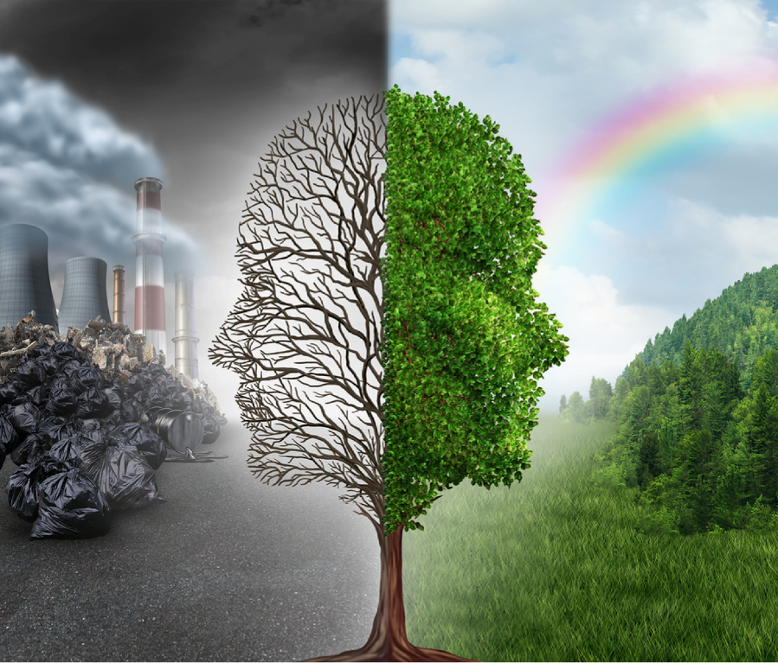
Our Body has its OWN Detoxification Process
When all systems are functioning in perfect harmony and we are not surrounded by daily toxic assault, our body’s elimination pathways would be enough. If we ate organic, non-GMO, whole foods with complete mineral and nutrient density; eliminated all bad thoughts, experienced no stress or trauma and faithfully led our lives to know all would be ok, we would need zero help regarding the elimination of toxins. The only toxins our body would have to worry about would be byproducts of our fully functioning systems, which the body would easily identify and eliminate in a timely manner. But let’s face it. We do not live in that perfect world. Daily, we are assaulted with toxins on a physical, emotional and spiritual level and must provide our body with the appropriate support to enhance elimination pathways for optimal health.
Negative Side Effects to Too many Toxins:
- Systems sluggish
- Toxins remain longer than they should
- Damage and inflammation
- Overstimulation of the immune system
- Organ dysfunction
- Emotional distress
- Poor assimilation
- Cellular mutation
- Weight gain
A Few Signs Your Elimination Pathways Need Support:
- Allergies
- Bowel movement irregularity
- Fatigue, low energy, difficulty getting out of bed
- Feeling bloated or sluggish
- Food intolerances
- Headaches
- High cholesterol
- Irritable moods
- Nausea
- PMS, menopausal and hormonal issues
- Problems shifting weight
- Skin problems such as acne
- Sleep disturbances, especially waking during the night between (see Chinese Meridian Wheel)
- Sinus issues
- Breathing issues
- Swelling
- Inflammation
- Recurrent bladder or kidney issues
- Dark circles under the eyes
- Joint issues
The Elimination Pathways
B - Bowels
U - Urinary
L - Lungs
L - Lymph
S - Skin
Bowel
The bowel is comprised of the colon, liver and gallbladder. This system of elimination does so much but for the purpose of this overview we will zoom in on a few processes. One way we rate the efficiency of this system is with normal daily bowel movements. We hear so many people say, “I don’t have a bowel movement everyday but my doctor says that is just my normal.” This simply is not healthy! I would agree with this statement if a person didn’t eat every day. Our body is designed to absorb nutrients and eliminate waste on a daily basis. If a person is eating daily than daily elimination is needed.
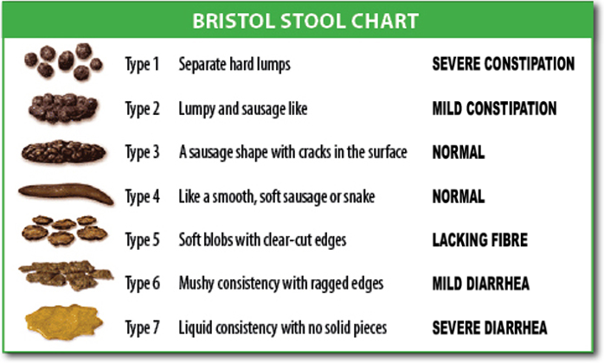
What is Normal?
Normal bowel function consists of daily bowel movements. These movements should be easily expelled from the body and shaped like a smooth banana. Any deviation from normal and healthy is a sign that this elimination pathway needs support. The chart above shows the deviation from normal on both sides of optimal.
Consistency: The bowel movements to the left of Type 4 indicates hard, cracked and pebbly stool. This type of bowel movement indicates dehydration. This type of individual may experience frequent constipation and painful bowel movements. This issue is unfortunately common in children due to lack of water consumption. For this issue the best advice is more water, fiber (fruits and vegetables) or probiotic based foods. Consistency to the right of Type four is an indicator that proteins are not being digested properly. Loose stools are common with dysbiosis of the digestive tract as well. Parasites, candida and other imbalances can lead to soft bowel movements or even frothy diarrhea.
Color: The color of bowel movements can easily vary with what a person eats, especially if they are not breaking down and absorbing those nutrients. While off-color bowel movements can indicate other issues. Although the color of stool is not a diagnostic tool, if the issue remains persistent it is always recommended to seek out the advice of a licensed medical professional.
- Brown: Normal
- Dark brown or black: Slow digestion (the stool is staying in the colon too long), old blood; could also be due to supplements such as iron or activated charcoal or foods like blackberries or blueberries
- Light brown or grey: lack of bile salts, medication side effect
- Yellow: Fat assimilations issues, low hydrochloric acid in the stomach, underlying infection
- Green: Consumption of leafy green vegetables, food coloring in the diet (watch for this with kids), may occur during certain times of pregnancy
- Red or bloody stool: May be due to food such as beets or red dyes, hemorrhoids (need for bioflavonoids) or a more serious condition. The higher in the digestive tract the bleeding, the older the blood will look upon exiting. Older blood will be darker while bleeding from the lower part of the digestive tract will be brighter red.
Sink or Float: Stools should sink! But again look at the consistency. If it sinks quickly and is hard or in pebble form this may be a confirming sign of dehydration. Occasional floating of stool is normal. This is an indication that gas is in the digestive tract that can occur after a consuming carbonated beverages. However, if a normal pattern for a client is floating bowel movements it may indicate poor fat assimilation or fermenting in the colon. Look deeper for issues with dysbiosis, (the overgrowth of candida.) Are you consuming enough good fats in your diet? There are a few other factors to highlight with daily bowel movements. A thin stool (diameter of a pencil) may indicate inflammation of the intestinal lining. Mucous in the stool may again be fat assimilation or an indicator of food sensitivities. All of these signs, although not diagnostic, lead to ask yourself better questions pertaining to diet, hydration, medications or anything else that may disrupt the elimination pathway.
The Liver and Gallbladder
The liver and gallbladder are also involved in this elimination pathway. Consider the liver the master multi-tasker with over 500 different roles in the human body. The liver is responsible for:
- Fat and carbohydrate metabolism
- Vitamin and mineral storage
- Immune function
- Detoxification
The liver plays a vital role in the detoxification process of the body. The liver filters the daily assault. One function of the liver is to convert fat soluble toxins to water soluble. This is referred to as Phase 1 & Phase 2 detoxification. During Phase 1 oxidation reduction and hydrolysis occurs. There is a class of enzymes that reside in the liver, P- 450. The function of these enzymes is to act as catalysts to these processes. When we are over exposed to toxins, this process can speed up, and dump too many toxins into the body. When the body is exposed to too many toxins at once, it can slow the filtration down and the person may become symptomatic. By keeping our environment clear (mind, body and spirit) or in balance, we help the liver deal with normal levels of toxicity.
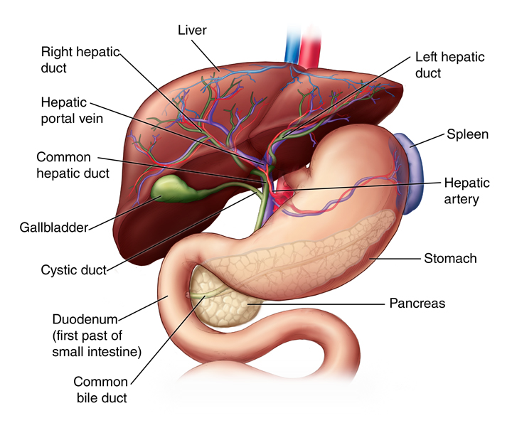
Phase 2 Detoxification (conjugation): The filtration of these toxins happens in phase two when the liver releases chemicals to bind with the toxins that renders them harmless to the body. This process also makes them water-soluble with the ability to be excreted via the urinary elimination pathway. While this is an elementary look at the process, it may give you a better idea of why a cleanse or detox can create a much different experience for some people, depending on their current state. It all comes down to supporting the elimination pathways, resetting them to normal function and to allow for the correct timing of the body.
Efficient phase two detox requires certain substances, including sulfur-containing amino acids and nutrients like glycine, glutamine, and choline. Luckily, these compounds are found in foods like cruciferous vegetables, garlic, and certain dark leafy greens and are helping the liver to keep up with the phase two detoxification process.
It also requires water! Remember the Foundations of Health are always what we build our health upon!
Urinary
The Urinary Elimination pathway consists of the bladder and kidneys. This is our water filtration system that runs 24 hours a day, seven days a week and 365 days a year without ever changing the filter. This pathway keeps our toxic load in check and support for this system is vital for quality function through life.
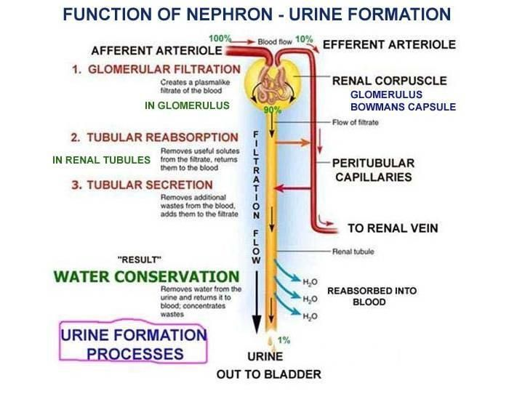
Functions of the Kidney:
- Regulates proper fluid balance
- Regulates proper mineral and electrolyte balance
- Regulates pH of the body
- Regulates hormone secretion
This pathway also takes converted fat-soluble toxins to water soluble toxins (a function performed by the liver) and excretes them from the body. When a person drinks minimal water, they have already compromised one of the pathways. The kidneys also rely heavily on mineral balance and establish the correct balance of minerals in our body. If our levels of minerals are not optimal, kidney function may be compromised. Several medications can inhibit the function of the kidneys and this pathway of elimination. It is important to understand the impact of each one. To optimize kidney function eat a colorful diet, drink plenty of clean water and consume healthy fats daily, to optimize kidney function.
The bladder is the dumping station for waste to be excreted. We want to eliminate the toxins quickly. Remember, timely elimination of toxins is important. Be sure to drink enough water to flush toxins and prevent any bacterial overgrowth. This will keep the bladder healthy, inflammation at bay, and all systems go!
Lungs
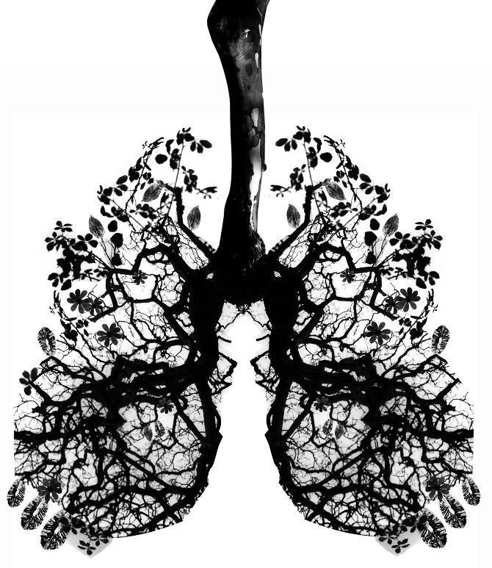
The lungs are primary in oxygenation of the body. Which means they must provide clean air, primarily Oxygen to the cells of the body for optimal health. The lungs also provide a pathway of elimination in the form of Carbon Dioxide, (a by-product of cellular metabolism.) Hemoglobin is a protein molecule that is found in red blood cells and aids in the transport of oxygen from the lungs to body tissue. As an added benefit, hemoglobin stimulates the internal process that returns carbon dioxide back to the lungs to be expelled from the body. When our breathing is compromised our elimination of CO2 is compromised and we begin to ‘suffocate’ our tissues. Remember the body must eliminate and do so in a timely manner. We don’t want toxins hanging out causing more damage.
Breathe deep daily. The Wim Hof breathing method is fantastic! It will enhance cellular metabolism and the elimination of waste products from the body.
A proper breath is diaphragmatic breathing or belly breathing. We want to inhale fully in a slow, steady pace (four counts in); fully extend the belly and keep the shoulders level. Hold that breath for a count of four seconds then exhale fully for a count of 10 seconds. Breathing techniques can also aid in the reduction of stress and anxiety and aids in balancing the autonomic nervous system which regulates breathing.
Polluted Air
Anything that affects air quality will affect our ability to oxygenate the system. Air contaminants such as working in an atmosphere where the air is not pure can lead to toxic build up. Heavily populated cities with a high industrial population or traffic will result in poor air quality. People who smoke participate in poor air quality daily.
A Few More Tips for Optimal Lung Function:
Drink enough water daily to help keep the mucosal lining of the lungs thin. We all realize how difficult it is to breathe when we are congested. Water is a great medium to carry things to and from our body.
Watch your posture, get chiropractic adjustments and stretch! Our lungs and diaphragm need space to expand. Be sure to sit up straight, stretch out muscles in your chest and get adjusted by a chiropractor to help enhance breathing.
Last, exercise is an incredible way to increase lung function and accelerate the elimination of toxins. Exercise increases VO2 max (maximal oxygen uptake, is the measurement of the maximum amount of oxygen a person can utilize during intense exercise), which in turn accelerates the metabolic breakdown of waste and bad cells (autophagy). Daily movement, enough to increase heart rate and respiration is crucial for proper elimination through the lungs.
Daily Tips for Better Breathing
- Plants in the household can decrease allergens and increase air quality
- Deep breathing techniques
- Support the lungs with antioxidant rich foods
- Stay hydrated
- Exercise
- Keep a healthy posture
“Breath is the finest gift of nature. Be grateful for this wonderful gift.” - Amit Ray
Lymph
The Lymphatic System is three times the size of your blood stream and is a complicated system of fluid filled nodes, vessels, glands and organs. It is our cellular cleanser. The lymphatic system’s main function is to cleanse toxins and protect against harmful invaders. It works by carrying our body’s waste away from the tissues and into the bloodstream. Once the toxins enter the bloodstream, they are purified through the largest lymphatic tissue in the body, the spleen. The spleen is our main immune defense. It fights infection, holds a reserve of red and white blood cells and destroys worn-out red blood cells in the body. The issue is the lymphatic system does not have a pump.
It literally does not move unless we move it. Not moving the lymphatic system results in a buildup of toxins and eventually creates issues in the body.
Exercise is great way to move the lymphatic system. Any movement that pumps the muscles will pump the lymph.
Enhancing lymphatic Function in a Variety of Ways:
- Dry skin brushing
- Lymphatic massage
- XTract Process
- Rebounding
- Enzymes
- Inversion Table
- Lymphatic Herbs
- Yoga or Exercise
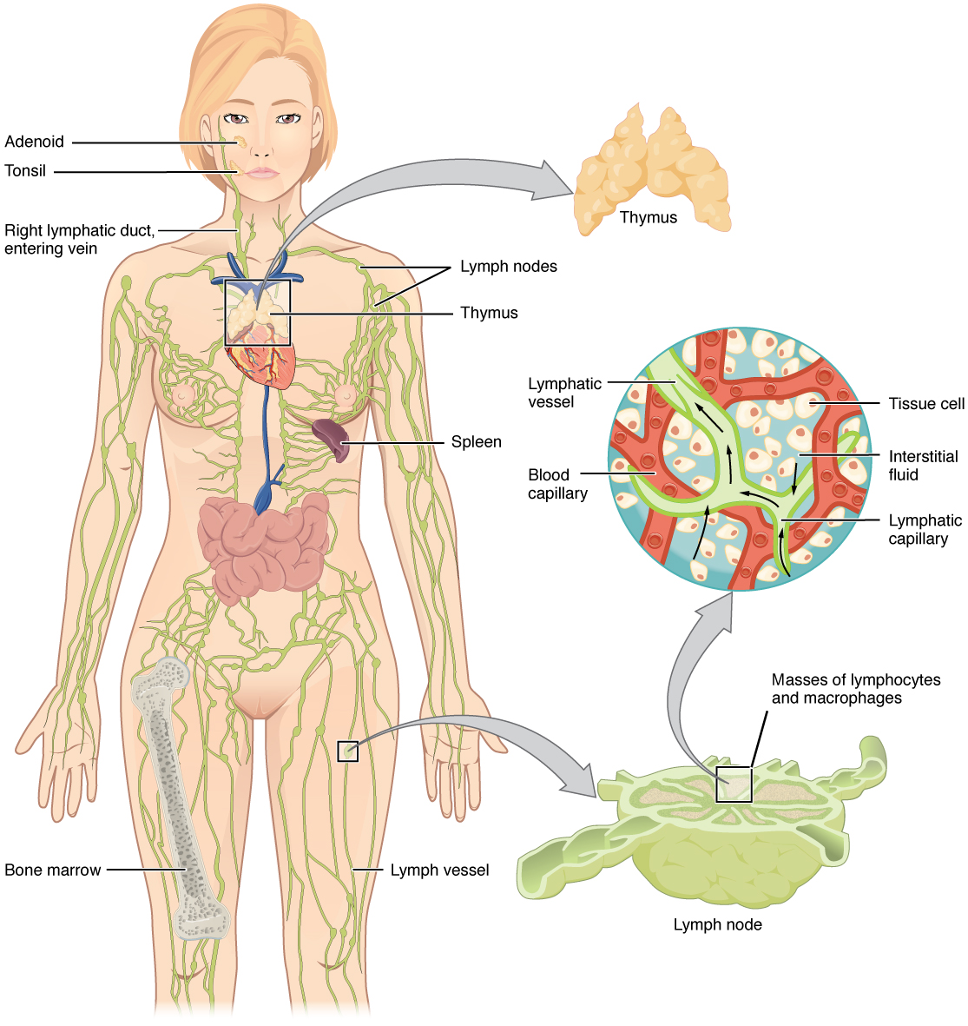
Optimal function of the lymphatic system results in killer T&B cells. “Lymph organs include the bone marrow, lymph nodes, spleen, and thymus. Bone marrow contains tissue that produces lymphocytes. B-lymphocytes (B-cells) mature in the bone marrow. T-lymphocytes (T-cells) mature in the thymus gland. Other blood cells such as monocytes and leukocytes are produced in the bone marrow. Lymph nodes are areas of concentrated lymphocytes and macrophages along the lymphatic veins. The spleen is similar to the lymph node except that it is larger and filled with blood. The spleen serves as a reservoir for blood, and filters or purifies the blood and lymph fluid that flows through it. If the spleen is damaged or removed, the individual is more susceptible to infections. The thymus secretes a hormone, thymosin that causes pre-T-cells to mature (in the thymus) into T-cells.
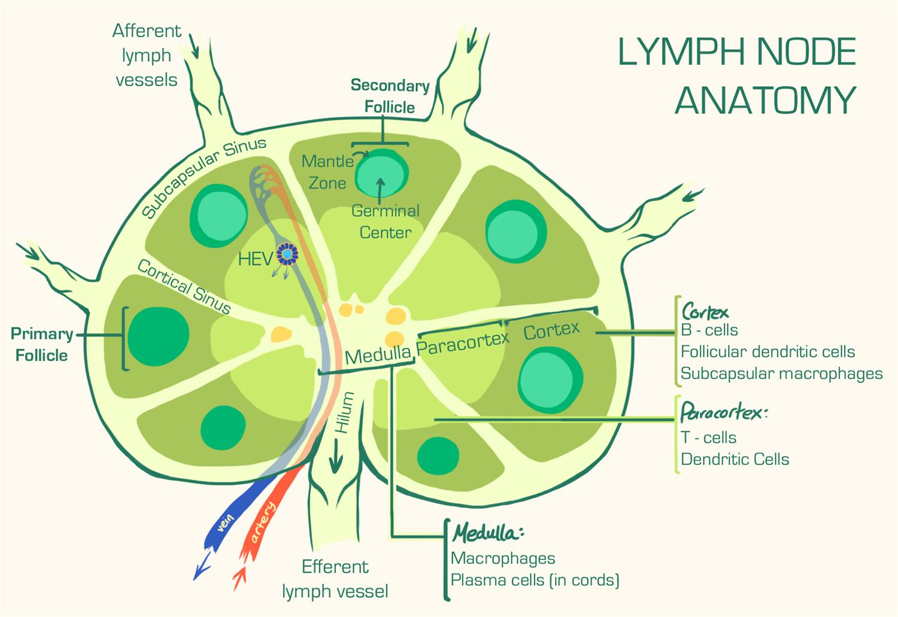
The Lymphatic System is a major elimination pathway and deserves the same attention as any other pathway for optimal function.
Skin
Before we leave the bathroom in the morning we expose our skin to nearly 300 chemicals. The skin is a fascinating organ because it does both absorption and elimination. Everything we put onto our skin either enhances or hinders its function. Also, anytime you put something on your skin it has the potential to be absorbed into the blood stream directly. This fact is the primary selling point for essential oils. However, even chemicals have this ability. Keep that in mind the next time you freshly mop your kitchen floor then walk barefoot over those chemicals. Our exposure to chemicals is daily. “It is estimated that more than 13 million workers in the United States are potentially exposed to chemicals that can be absorbed through the skin.” ~ Center for Disease Control and Prevention. In the home or at work your skin is your fist line of defense against toxic assault.
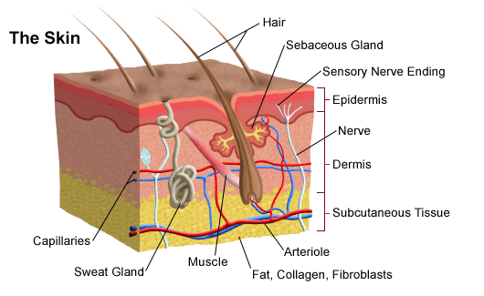
Keeping the Pathway Open:
- Use less chemicals topically. Keep the pathway open by using less chemical based products on the skin. Coconut oil is a great alternative moisturizer. Choosing organic skin products, makeup and cleansers.
- Eat good fats. Good fats and beautiful skin go handin-hand. Although the top layer of skin is primarily dead, it is what lies beneath and the health of skin that determines the functionality.
- Antioxidants daily. Antioxidants fight free radical damage and help with toxic overload.
- Quality supplements. Build from the inside out. When we see something come out on the skin we need to know that this is a sign that other pathways are not getting toxins out fast enough.
- Sweat. Exercise, infrared saunas, detox baths anything that will cause the body to sweat and detoxify the system.
- Stay Hydrated. Remember water is a Foundation of Health and the medium for each elimination pathway.
- Keep the microflora healthy. Our body and skin has a natural probiotic covering. These are good bacteria that help protect us from toxic assault and aid in the detoxification process. Limit the use of anti-bacterial soaps and hand sanitizers, which destroy our microflora and decrease our natural immunity.
Signs of Issues with the Skin as an Elimination Pathway
- Excessive sweating
- No sweating
- Rash
- Blotching color
- Acne or pimples
- Wrinkles Spots
- Dry skin
- Oily skin
- Lesions, growths
- Easily damaged
Elimination: Conclusion
Daily Exposure to Toxins:
- Negative people
- Food dyes
- Preservatives
- Additives
- Glyphosate
- Pesticides
- Radiation
- Chemicals
- Electromagnetic Waves
- Trauma
- Heavy Metals
- Parasites
- Candida
- Pollution
- BPA
- Phalates
Signs your Body is Detoxifying Optimally:
- You feel energized
- You tend to sleep through the night
- Your mood often improves because you generally feel better
- Menstrual cycles are ‘easier’ with fewer symptoms like cramps and moodiness - menopause is less challenging due to effective hormone clearance
- Weight management is easier
- Beautiful, clear skin
- Improved digestion and absorption
- Healthy immune system
- You maintain healthy cholesterol levels
- Your body can more easily repair and restore
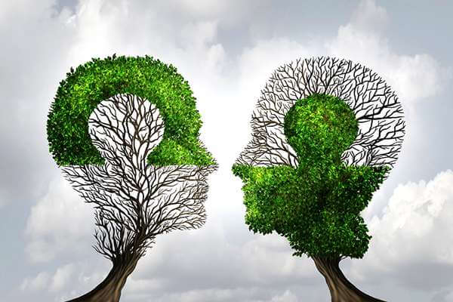
Elimination is a great way to take a foundational step in regaining health. Eliminate negativity, drink more water, eat more fiber, take the right supplements to support organs and a few deep breaths a day may be just what the doctor ordered. Overall our daily exposure to toxins can negatively affect our health. We will touch more on emotional toxins in our next section.
“Give me good digestion, Lord, And also something to digest; but where and how that something comes I leave to Thee, who knoweth best.” - Mary Webb
Emotional Wellness
Our emotional wellness is comprised of thoughts, feelings and emotions and how we handle them. Emotional wellness inspires self-care, stress reduction, relaxation and releasing trapped emotions. Today there is an amazing amount of emphasis on emotional wellness. We are so stressed due to the hurry up lifestyle and instant gratification of society. Our physical bodies are definitely feeling the impact with increased blood pressure, heart attacks, depression and anxiety. And stress is stress. Both good stress like the excitement of a wedding day or bad stress like being fired from a job cause the same chemical reactions in the body. Utilizing natural techniques internally and externally can make all the difference in our sustained health.
Types of Stress
Survival Stress: This includes “fight or flight” reactions in times of peril but can also mean survival at work, at home or in everyday activities. You can be stressed about keeping your job and being able to provide for yourself or your family.
Internal Stress: This would include over thinking a situation or worrying for no reason at all. This is common and comes from a tense lifestyle. Because of this many people’s adrenal glands and chemical reactions are thrown off, pushing them into depression and anxiety.
Environmental Stress: Our bodily response to things around you such as noises, crowding, pressure from work or your family. Identifying environmental pressures and avoiding or dealing with them can help lower stress level.
Fatigue and Overwork: Too much work, pressure at work, school, or at home can all contribute to fatigue and in turn cause stress. Many people feel that this type of stress is out of their hands and is uncontrollable, making it one of the hardest stresses to relieve. “Stress symptoms may be affecting your health, even though you might not realize it. You may think illness is to blame for that nagging headache, your frequent insomnia or your decreased productivity at work. But stress may actually be the culprit.” ~ Mayo Clinic
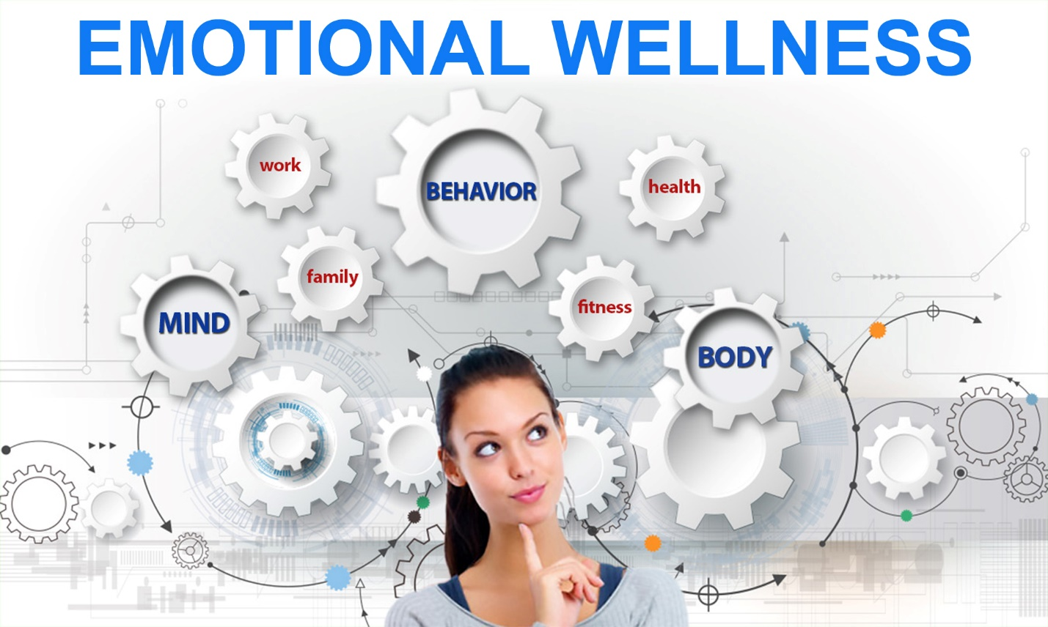
Health is a Triangle: Physical, Emotional and Spiritual
Looking just at the physical body is not enough to attain total wellness. To fully gain optimal health we must look at health in a different way: Health is a triangle. It is comprised of physical, emotional and spiritual wellness. To have optimal health you must find balance between the three. Our society has the tendency to look at physical first but in most other cultures, the emotional wellness of a person is most important.
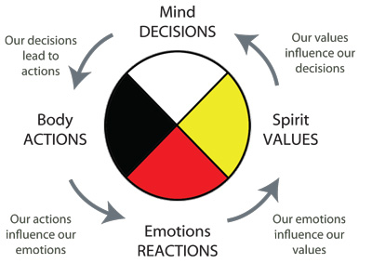
Self-care means taking care of your physical body and your emotional self. Some examples may be eating healthy, exercising, drinking plenty of water and getting good sleep. Sound familiar?
Relaxation is Vital for Attaining a Healthy Lifestyle
Relaxation Techniques:
- Meditation
- Massage
- Reading
- Praying
- Hot bath
- Hobbies
- Exercise
- Yoga
- Tai Chi
- Listening to music
Stress Reduction
Reducing stress may require more personal boundaries or simply saying no. We have become a YES society and it has truly cost us our health. Time management and priorities are key in reducing stress. When you put your health first we have the ability to achieve everything else. If we don’t have our health we don’t have anything.
Releasing Trapped Emotions
Practitioners from all over the world, 3000 years of Traditional Chinese Medicine and yes, yours truly, recognize the fact that emotional wellness directly affects the physical body. Even western medicine is beginning to understand the impact. Releasing these trapped emotions is a great way to enhance a program towards optimal wellness. In Traditional Chinese Medicine each organ represents an emotion. If you understand the emotion associated with an organ it may give a clue to the underlying issue. When nothing else is working for the issue you are addressing, address the emotions! An example of this is Christopher Reeves (a.k.a. Superman) who passed away a few years after becoming a quadriplegic. One year after his death, his wife died of lung cancer. She never smoked a day in her life. In Chinese Medicine the lung represents unexpressed grief. There are several techniques of emotional release such as emotional code, flower essence and Emotional Freedom Technique to name a few. It would be good to have one or all of these in your toolbox.
Organs and Emotions
- Liver - Anger or Frustration
- Gallbladder - Resentment
- Kidney - Fear
- Pancreas - Deep want or Lack of Joy
- Lungs - Grief
- Bones - Resentment
- Joints - Rigidity
- Muscles - Guilt
- Tendons/Ligaments - Inflexibility
- Temporal Headache - Repressed Anger
- Colon - Stuck in Life or Repression
- Bladder - Irritability
- Spleen - Obsessive Worry
- Stomach - Worry or Apprehension
- Skin - Unworthy
- Nerves - Communication Imbalance
- Thyroid - Repressed Expression or Over Expressing
- Heart – Love
Emphasizing the Other Foundations
Tony Robbins emphasizes five pillars of success. The very first pillar he talks about is having the physical ability to attain, maintain and sustain the path. This concept can easily translate to life. Our physical body is a place of experience. We experience all of our senses here. It’s like a battlefield where the emotional fight takes place. If this is the case, preparing our physical body for the emotional management will assist in overcoming the battle. Start with what you can control, then move on to all the other foundations. We can certainly build our physical body so when stress arises we have the physical stamina to overcome and the ability to sustain the battle. We can’t always control what happens to us but we can prepare for it and control how we react to it.
Our Spiritual wellness is the last piece of the triangle. Whatever your faith, investing time in your spiritual growth and connection can have many health benefits. This can include daily prayer, ritual or meditation; a centering of self and connection to a higher power or greater good.
Emotional wellness is fast becoming the focus of health today and for good reason. When you are sick you have been brainwashed to suppress the symptom and keep going. Sometimes the symptom is the result of an emotional issue rather than a physical one. Repressed emotions will eventually create DIS-ease of the body and affect the total health of the person.
Summary of the Foundations of Health
There is not pill or program that will fix you. It is a process of gradient steps, putting one foot in front of the other and building a strong foundation to rest your healthy life upon. Build the Foundations of Health first!
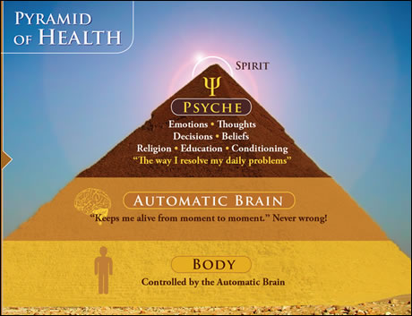
Depletion of Nutrients
Did you know? JAMA changes their position for the first time in 40 years from “eat right” to “eat right and take a multivitamin” - Journal of the American Medical Association, June 2002 –
The US has lost up to 80% of the nutritional content in produce in the last 50 years due to environmental toxins.
- The U.S. grows genetically modified organisms GMO’s – which are illegal in many countries.
- Industrial chemicals are now allowed to be used as additives to our food without any significant testing for safety.
- Some chemical additives are withheld from labels when they are in small enough amounts or if they are categorized as “others”.
Importance of Supplementation
It is becoming harder to get the nutrients our bodies need to live a healthy life due to poor soil, environmental toxins, and genetically modified foods.
Most people now eat 60% of their meals “on the go” or dine out. While there’s nothing wrong with going out now and then, 60% is excessive and most restaurant options are not healthy.
"In A Sea Of Possibilities - Pattern Recognition Is The Key To Unlocking The Door To New THERAPEUTIC Interventions"
Joey Phillips - Owner & Founder
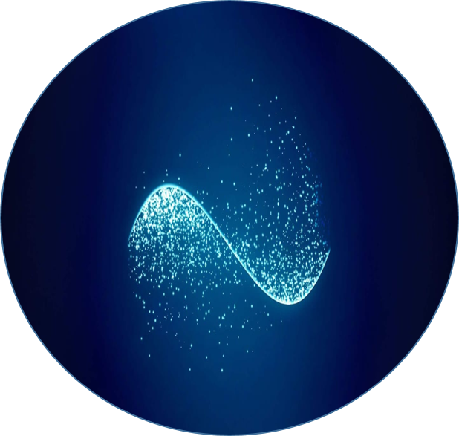

www.dna-diligence.com
Book Now
https://www.dna-diligence.com/book-online
All Rights Reserved®

